Naïve Bayes Algorithm

A 2-class Naive Bayes algorithm with an apriori decision rule using a multinomial estimation for the classes and a gaussian estimation for the attributes

. The formulas:

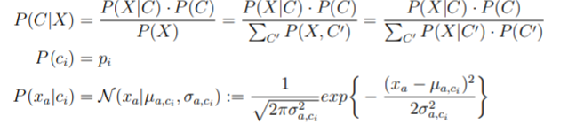

where xa is an instance x with an attribute a and µ and σ being the parameters of the Gaussian. The parameter estimates are given as follows:

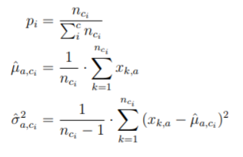

Where nci is the amount of instances for class ci .

Format of output file:

